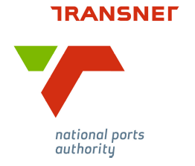

PRE-ARRIVAL DETAILS FOR ARRIVAL AT THE SOUTH AFRICAN PORT OF:
SALDANHA BAY

Ship details
Name: | ANGELE N
Port of Registry: | HONG KONG
Call sign: | VRFI8
IMO number: | 9509528
Type of vessel: | BULK CARRIER
Estimated Date & Time of Arrival: | 19-03-2017 2000UTC

Voyage details
Day, month, and time the report is made: | 13-03-2017 0600UTC
First port of call: | Saldanha Bay
Last port of call: | GANGAVARAM,INDIA
Next port of call: | Dunkirk, FRANCE

Security details
Security level at which the vessel is operating: | 1
Expiry Date of ISSC: | 16-06-2020
Name and rank of SSO: | MASTER:CHU JIAYAN
Name of Company Security Officer (CSO): | CAPTAIN:THEODOROS GAD
Contact Details of CSO: | TEL:+30 6973 773 996
Crew list | SEE ATTACHMENT
Passenger list | NIL
List of Any Other Persons Aboard | NIL

General description of cargo on board
Cargo: | NIL
Cargo: | NIL
IMDG classes of cargo on board | NIL

Master of MV Angele N

